

CARA v5.6 Configuration Training

Student Lab Book

May 2022

Authored by:

Barry Prince, Generis Head of Training & Curriculum

For any questions or suggestions please email: barry.prince@generiscorp.com

Table of Contents

Introduction 3

Type Definition 4

Dictionaries & Taxonomies 6

Workspaces 9

Forms 11

View Actions 15

View Aggregations 16

View Grid 18

View Search 20

View Widgets 22

Classification Definition 24

Template Assignment 25

Auto-Values & Sequences 26

Linking 28

Lifecycles 31

Lifecycle Assignment 33

Workflow Templates 34

Test Your Configuration 40

Export Your Configuration 43

# Introduction

This lab book guides users through the exercises which accompany the CARA v5 Configuration training course.

The labs are based around a scenario where an organisation is implementing an eTMF (Trial Master File) solution using CARA. In the eTMF solution documents are classified by eTMF zone and section. The principles explored in the labs can be applied to any CARA v5 implementation.

Details of how to connect to the CARA training environment are provided by the course instructor.

An important note about the syntax used within these labs:

**Where this lab book refers to studentx or TMF Studentx please substitute with the student number provided to you, for example student3 and TMF Student3.**

Items in **Bold** point to an item or menu visible within the CARA user interface.

# Type Definition

Type definition determines the types of documents and other objects which users will create, view and work with. A CARA implementation may include document types which are used across the organisation, and others which are specific to a department or process.

The definition of document/object types and their properties is a significant consideration for any CARA implementation.

As organisations evolve their use of CARA they may want to add new object types, for example when additional departments start using CARA. They may also want to add additional properties to the existing object types.

In this example we will define a new document type named tmf_studentx and specify its custom properties. This type will be the basis for all user generated documents in the training environment. Most of the labs which follow in this course will be concerned with fine tuning the configuration of this type.

Core attributes such as document name, created date and version label are predefined for all types, we only need to define additional type specific attributes.

1. Within CARA open the **Control Panel** in the top-right corner of the user interface.
2. Within the **Administration** section click the **Type Definition** node.
3. **Add** a new type definition.
4. **Type Name** = tmf_studentx
5. **Display Name** = TMF Studentx
6. Select an **Icon**.
7. **Purpose** = Documents.
8. **Content Storage** = CARA Filesystem Connector.
9. **Content Processing.** Select **Indexed for Search** and **Render PDF Automatically**.
10. **Versioning** = Advanced Versioning with Lifecycle.
11. **Folders** = Automatic Folder Linking Based on Rules.

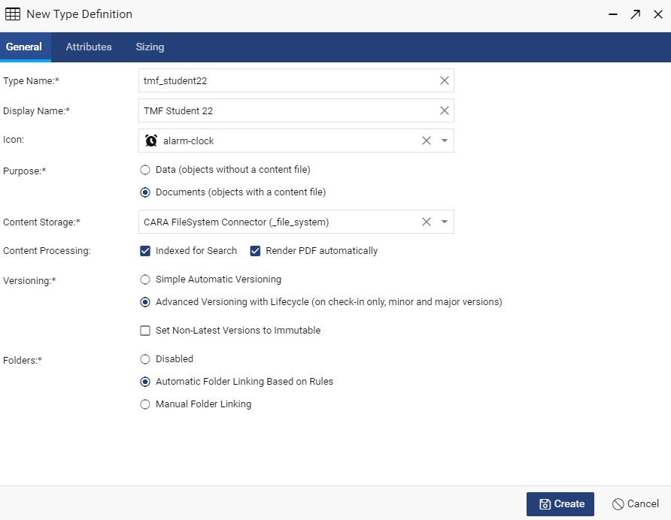

1. In the **Attributes** tab **Add** the following single value attributes:

* Name: zone

Display Name: Zone

Data Type: String

* Name: section

Display Name: Section

Data Type: String

* Name: unique_id

Display Name: Unique ID

Data Type: Integer

* Name: subject

Display Name: Subject

Data Type: String

1. In the **Sizing** tab set Estimated Document Count to 1000 and do not disable data replication.
2. **Create** the new type definition.

# Dictionaries & Taxonomies

A dictionary is a pick-list provided to users to select values from, typically on the properties form of a document. A taxonomy is where 2 or more dictionaries are linked, a choice made in a parent dictionary determines the choices available in a following child dictionary e.g. where users need to select a document’s region and country, the choice of region, such as Europe, determines the subsequent countries that can be chosen.

In order for users to be able to create documents, the main classification must be configured (in a later lab). The main classification uses a taxonomy to provide users with the choices of the kinds of documents they can create e.g. general, clinical, quality etc..

In this lab we will create dictionaries for TMF zone and section and then a corresponding taxonomy which links these choices and will be used for the main classification. When creating new documents, users will select a document’s TMF zone and then section.

1. Within CARA open the **Control Panel** in the top-right corner of the user interface.
2. Within the **Data** section click the **Dictionaries** node.
3. **Add** a new dictionary. In the **New Dictionary - Properties** window add the following details:
   * **ID** = studentx_zone
   * **Display Name** = Studentx Zone
   * **Max Key Length** leave blank.
   * **Options**. Tick Disable Automatic Value Sorting.
   * **Aliases**. Add **Name** = en with **Max Length** = 32. Update the alias.
   * Click **Next.**
   * In **New Dictionary – Values** window **Add** the following active values:
   * **Key** = regulatory with **en**: = Regulatory.
   * **Key** = site management with **en**: = Site Management.
   * **Key** = Trial Management with **en**: = Trial Management.
   * **Save** the studentx_zone dictionary.
4. **Add** a second dictionary with the following details:
   * **ID** = studentx_section
   * **Display Name** = Studentx Section
   * **Max Key Length** leave blank.
   * **Options**. Tick Disable Automatic Value Sorting.
   * **Aliases**. Add **Name** = en with **Max Length** = 32. Update the alias.
   * **Add** the following active values:
   * **Key** = General with **en**: = General.
   * **Key** = Meetings with **en**: = Meetings.
   * **Key** = Site Setup with **en**: = Site Setup.
   * **Key** = Trial Oversight with **en**: = Trial Oversight.
   * **Save** the studentx_section dictionary.
5. Close the Dictionaries window.
6. Within the **Data** section click the **Taxonomies** node.
7. **Add** a new taxonomy.
8. In the **New** **Taxonomy** **- Properties** window specify the name of the taxonomy and which dictionaries are linked and in which order:
9. **ID** = studentx_main_classification
10. **Display Name** = Studentx Main Classification
11. **Level 1** dictionary = Studentx Zone
12. **Level 2** dictionary = Studentx Section
13. Click **Next.**
14. Click **Add Item**.
15. In the **Add Items** window select all values and place them in the following order: Regulatory, Site Management, Trial Management and then **Save**.
16. **Add Sub-item**s to the top level items as below:

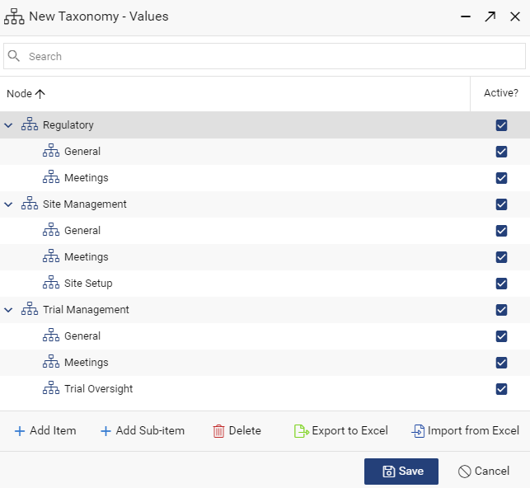

1. **Save** the new taxonomy.
2. Close the **Taxonomies** window.

# Workspaces

Views are grouped together into workspaces. Each new type definition has a default view created automatically, but the view needs to be added to a workspace before it can be used.

Each view can be included within multiple workspaces.

Users can have access to a multiple workspaces.

1. Within CARA open the **Control Panel** in the top-right corner of the user interface.
2. Within the **General** section select the **Workspaces** node.
3. **Add** a new workspace.
4. **ID** = studentx
5. **Display Name** = Studentx
6. **Views**. Open theviewselection window and select the default view for your type TMF Studentx (tmf_studentx). **Save** the view selection.
7. Leave the **Restrict to the Following Groups** and **Administrators** fields blank.

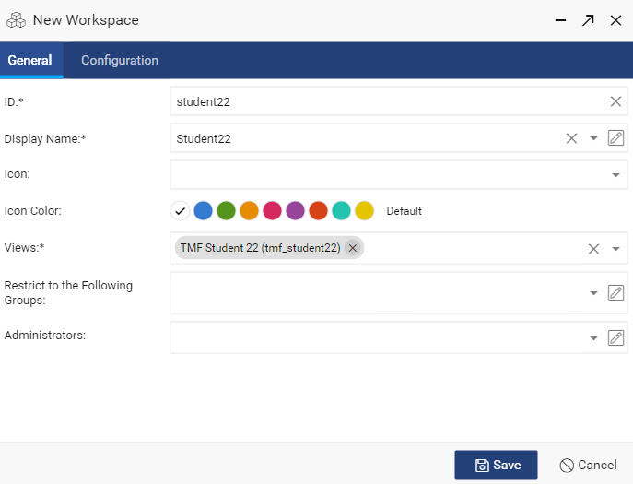

1. **Save** the new workspace.
2. Close the **Workspaces** window.
3. Close the **Control Panel** window.
4. Refresh your browser.
5. Select the Studentx workspace in the left-side user interface menu.
6. The TMF Studentx view tab should be visible on the view bar. The view will have minimal default configuration and no documents or other objects are yet available to view. The view will be configured in subsequent exercises.

# Forms

Forms display document/object properties to users. When users create documents a type specific form is presented to them where they enter attribute values. The form is also provided for viewing and updating attributes of existing documents.

When adding attributes to a form, multiple field types are available such as free text, drop-down lists and radio buttons. Drop-down lists use a dictionary or other value assistance to provide a list of values to choose from.

Each attribute can have conditions which determine when the attribute is visible, editable or compulsory.

Attributes on a form could be simply laid out one after another, but are typically grouped together into a series of tabs or within grids.

The form designer window is divided into **Structure** panel on the left and **Preview** panel on the right.

1. Within CARA open the **Control Panel** in the top-right corner of the user interface.
2. In the **Type Configuration** section select your type.
3. In the type configuration window for your type highlight **Form** and select **Edit**.
4. In the **Structure** panel of the form designer window begin by setting the overall dimensions of the form, highlight the **Form** node and select **Edit**.

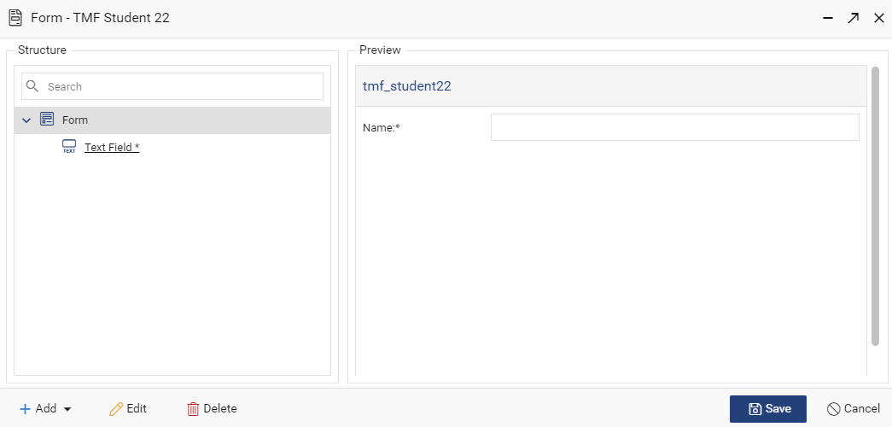

1. In the **Edit Form** window set the following:
2. **Header**: TMF Document Form.
3. **Form Width**: 600
4. **Form Height**: 500
5. **Save** the overall form properties.
6. Highlightand **Delete** the field named **Text Field\***
7. Highlight the **Form** node and **Add** a **Tabs** bar. In the **New Tabs** window set the **Internal Name** to tab bar 1. Users will not see the internal name. Save the **New Tabs** settings.
8. Highlight the **Tabs: tab bar 1** node in the **Structure** panel and **Add** a new **Tab** (**Tab** should be the only **Add** option at this point).

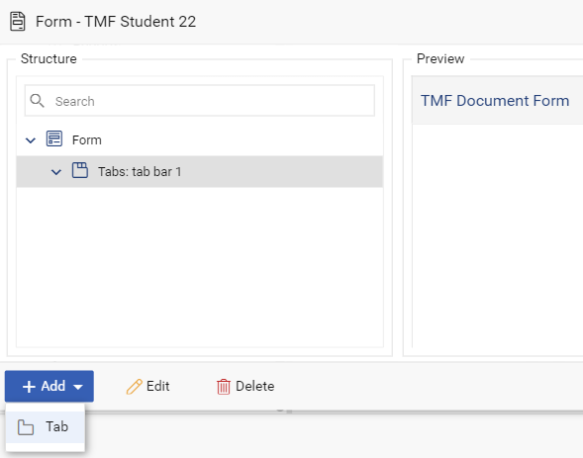

1. In the **New Tab** window set the **Internal Name** as General and **Label** as General Properties. Leave other options as default and **Save**.
2. **Add** and then **Save** another **Tab** with **Internal Name** as System and **Label** as System Properties.
3. In the **Structure** panel highlight the **Tab: General** node and **Add** a **Text Field**.

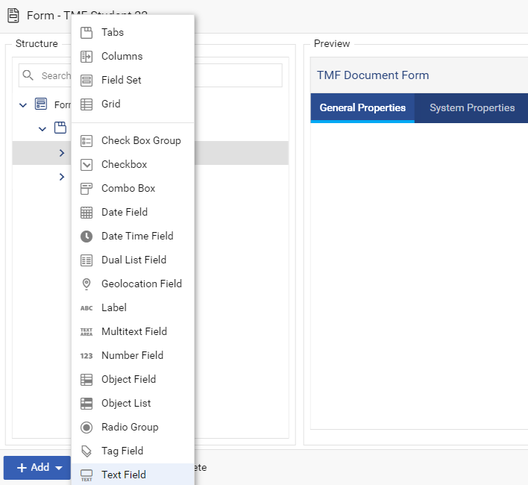

1. In the **New Text Field** window set **Property** as object_name, **Internal Name** as Name and **Label** as Document Name. Leave other options as default and **Save**.

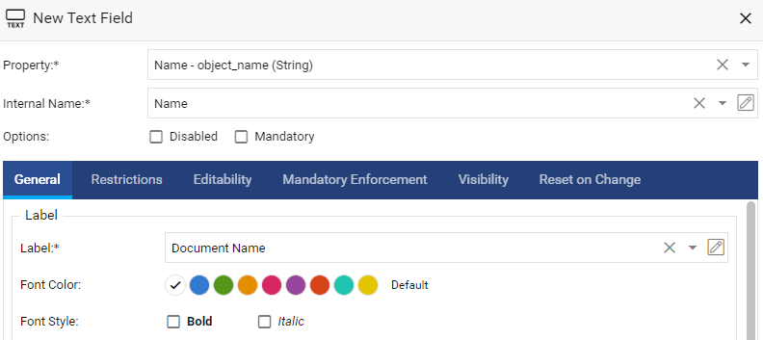

1. Add the following additional fields to the **General** tab:
2. Type: Text Field.

* Property: doc.subject
* Internal Name: Subject
* Label: Subject

1. Type: Number Field

* Property: doc.unique_id
* Internal Name: Unique id
* Label: Unique ID

1. Add the following fields to the **System** tab:
2. Type: Date Time Field

* Property: Created
* Internal Name: Created
* Label: Creation Date

1. Type: User/Group Field

* Property: Creator
* Internal Name: Creator
* Label: Created By

1. **Save** the form.

# View Actions

Actions are the toolbar buttons and right-click menu options made available to users. The available actions are configured per type view. Custom actions can be added as actions to the toolbar or right-click menu.

The double-click action can also be set within the Actions configuration window.

1. Within CARA open the **Control Panel** in the top-right corner of the user interface.
2. In the **Type Configuration** section select your type.
3. In the type configuration window highlight the default **View** and select **Edit**.
4. In the view configuration window select **Actions**.
5. In the Actions window leave the default **Double-click Action** as open **Properties**.
6. Select all available actions as both **Toolbar** and **Context Menu** actions.
7. **Save** the actions configuration.

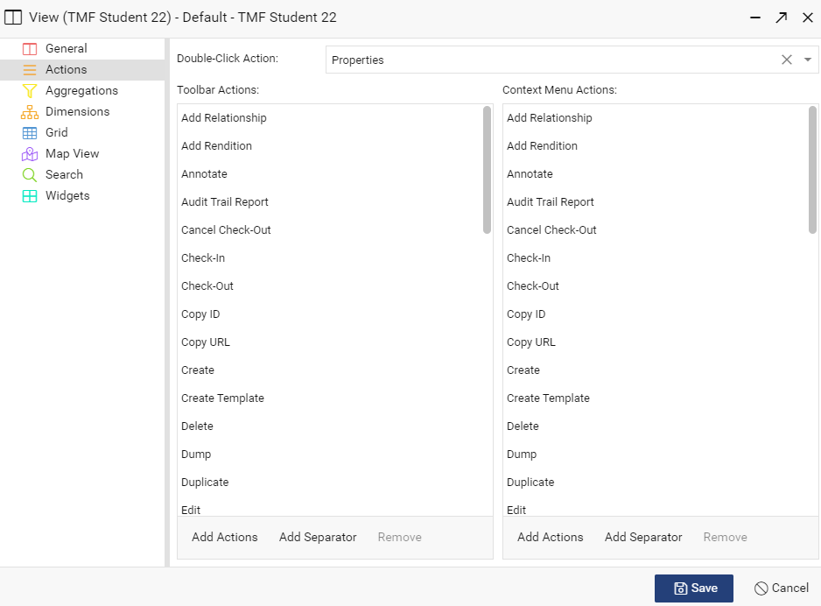

1. **Save** the View configuration.

# View Aggregations

Aggregations are user selectable filters which can be applied to the documents listed in the main view panel. Aggregations are selectable in the left-hand navigation panel.

1. Within CARA open the **Control Panel** in the top-right corner of the user interface.
2. In the **Type Configuration** section select your type.
3. In the type configuration window highlight the **View** and select **Edit**.
4. In the view configuration window select **Aggregations**.
5. In the **Aggregations** window **Add** a new aggregation with the following settings. Where settings are not specified leave the defaults:
6. **Type**: Terms
7. **Attribute**: doc.zone
8. **Header**: Zone
9. **Save** the new aggregation.
10. **Add** the following additional aggregations.
11. **Type**: Terms

* **Attribute**: doc.section
* **Header**: Section

1. **Type:** DateHistogram

* **Attribute**: Created
* **Header**: Month Created
* **Interval**: Month
* **Format**: MM-yyyy .Please note MM must be uppercase.

1. **Save** the aggregations configuration.

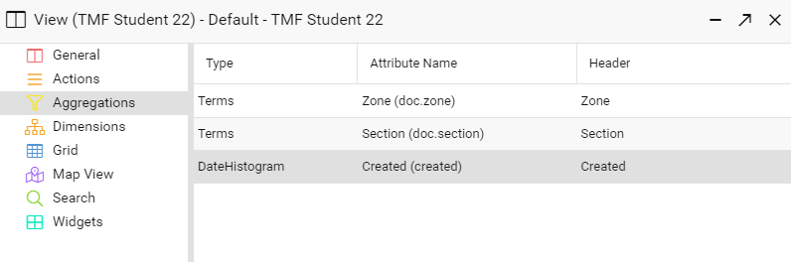

1. **Save** the view configuration

# View Grid

Grid refers to the column layout for displaying document attributes in the main view panel, located in the centre of the user interface.

The properties to be displayed need to be selected, with user friendly labels, size and alignment options defined.

The styles and icons used within the main view panel can also be customised. The styles and icons applied to documents are based on conditions.

1. Within CARA open the **Control Panel** in the top-right corner of the user interface.
2. In the **Type Configuration** section select your type.
3. In the type configuration window highlight the **View** and select **Edit**.
4. In the view configuration window select **Grid**.
5. In the **Columns** tab set the following attributes to be visible and sortable with default width and alignment settings :

* object_name
* version_label (needs to be added)
* created
* creator
* modified
* modifier

1. Select object_name as the **Sort By** field.
2. Set **Page Size** to 100.

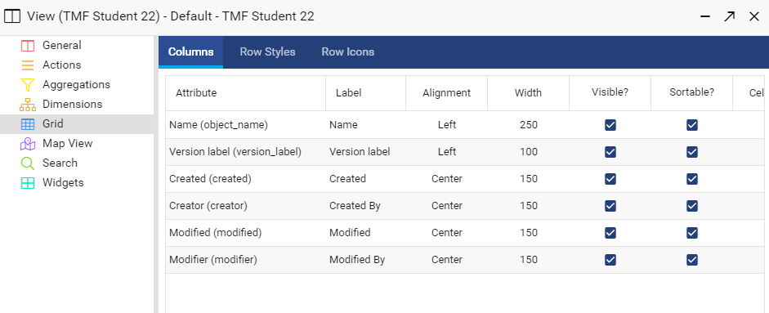

1. In the **Row Styles** tab **Add** and then **Update** the following row styles:
2. **Condition**: version_label=’Approved’. **Color**: green.
3. **Condition**: version_label=’Superseded’. **Color**: red.

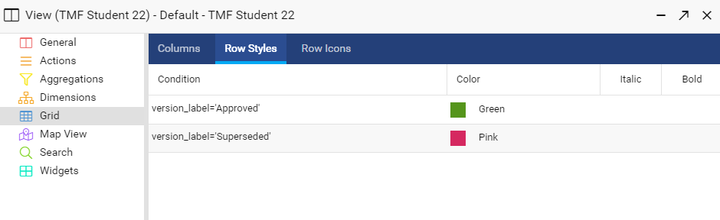

1. **Save** the aggregations configuration.

# View Search

Search configuration determines the behaviour of the quick search, including if full text search is enabled. Version filters and tags can also be configured for the view.

1. In the type configuration window highlight the **View** and select **Edit**.
2. In the view configuration window select **Search**.
3. In the **Quick Search Attributes** tab **Add** and then **Update** the following attributes with **Boost** as 1:

* object_name. (already present)
* content.data.
* doc.subject.

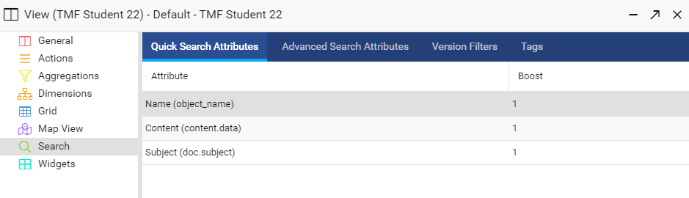

1. In the **Advanced Search Attributes** tab **Add** the following attributes with the following operators:
   * object_name with contains, is, begins with
   * content.data with contains
   * doc.subject with contains, is
   * created with is, after, before, within

Once saved it should look as follows:

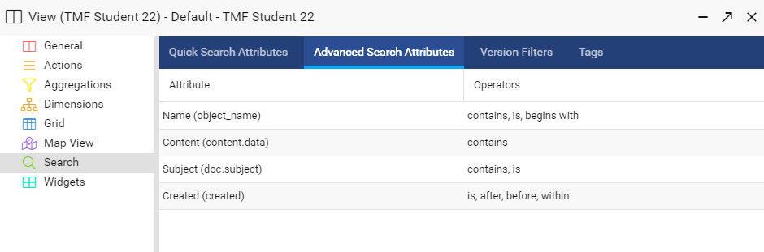

1. In the **Tags** tab **Add** the following tags:
2. **ID**: mydocs

* **Display Name**: My Documents
* **Condition**: creator=user

1. **ID**: mylocked

* **Display Name**: My Locked Documents
* **Condition**: lock_owner=user

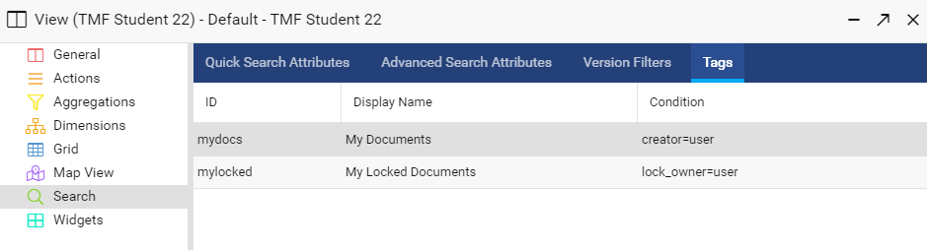

1. **Save** the search configuration.

# View Widgets

Widgets provide detailed information about the document currently highlighted in the main view panel. The Widgets panel is located on the right-hand side of the user interface and can be minimized and resized as per user preference.

Most widgets simply need to be enabled, others such as the attributes widget require configuration to be set.

1. Within CARA open the **Control Panel** in the top-right corner of the user interface.
2. In the **Type Configuration** section select your type.
3. In the type configuration window highlight the **View** and select **Edit**.
4. In the view configuration window select **Widgets**.
5. **Add** the following widgets with **ID** as default and an appropriate **Header**:
6. **Attributes** widget with the following attributes:

* acl_name.
* created.
* creator.
* lifecycle_name.
* lifecycle_state.

1. **Content/Renditions** widget. **Hidden Format** should be left blank.
2. **Locations** widget.
3. **QR Code** widget. Leave the settings as default.
4. **Versions** widget with the following attributes. All attributes should be **Visible**, **Sortable** and use the default **Alignment** and **Width** options:

* version_label.
* version_comment.
* creator.

1. **Save** the widgets configuration.

# Classification Definition

Classification definition involves specifying the taxonomy from which users select a classification when creating new documents or other objects.

Not all levels within the taxonomy have to require a user to make a selection, some levels may be set as optional, for example users might be required to select a zone that the document applies to at the top level, but a secondary level for section could be left as optional if some documents apply across sections.

Each classification choice that a user makes is stored as a distinct attribute value of the document, for example a user chooses a document’s zone and section and those choices are stored in corresponding attributes.

1. Within CARA open the **Control Panel** in the top-right corner of the user interface.
2. In the **Type Configuration** section select your type.
3. In the type configuration window select **Add** > **Initialization** > **Classification** **Definition**.
4. **Taxonomy**: select your taxonomy Studentx Main Classification
5. **Level 1 Attribute**: doc.zone
6. **Level 2 Attribute**: doc.section
7. **Required** **Levels** for documents: 2
8. **Required Template Levels**: 1
9. **Save** the classification definition.

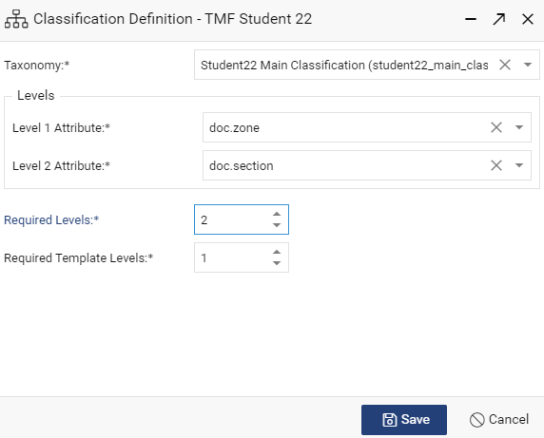

# Template Assignment

Until Template Assignment has been configured, no content templates are available to users. It is used to specify which template versions are made available to users for each classification, either the LATEST version or those with a specified version label, for example Approved.

Although template assignment is used to determine which versions of applicable templates are made available, it does not impact the overall selection of templates, which is based on the classification each template was given at the time it was imported or created.

It is also used to determine which attribute values, if any, will be inherited from templates.

1. Within CARA open the **Control Panel** in the top-right corner of the user interface.
2. In the **Type Configuration** section select your type.
3. In the type configuration window select **Add** > **Initialization** > **Template Assignment**.
4. Highlight the root classification node tmf_studentx and untick **Settings Cascade from the Parent Classification**.Set **Template Availability** to **Latest Version**.
5. **Save** the template assignment configuration.

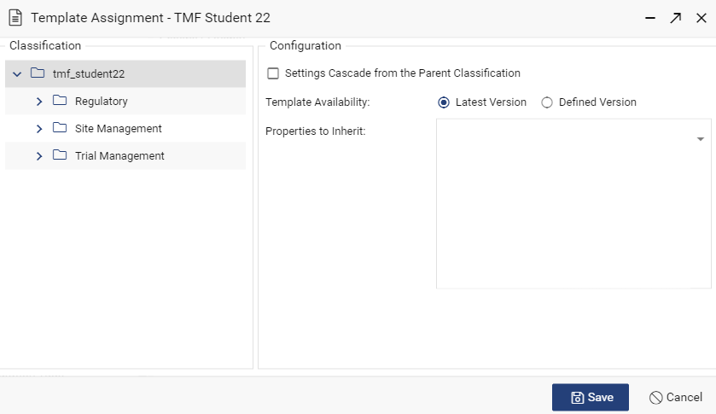

# Auto-Values & Sequences

Auto-values configuration allows property values to be set automatically based on a condition, when a document is checked-in.

Please note that auto-values differs from properties initialization, which are set only when the document is initially created.

Sequences are used to uniquely number documents. Sequences are primarily used as elements within auto-value rules.

In this lab you will create a sequence and use it in a new auto-value rule.

1. Within CARA open the **Control Panel** in the top-right corner of the user interface.
2. In the **General** section select **Sequences**.
3. **Add** a new sequence with the following properties:
   * **ID**: studentx_sequence
   * **Display Name**: Studentx Sequence
   * **Start Value**: 1
   * **Increment By**: 1
   * **Format**: 0000
4. **Save** the new sequence and close the **Sequences** window.
5. In the **Type Configuration** section select your type.
6. In the type configuration window select **Add** > **Processing** > **Auto-Values**.
7. **Add** a new auto-values rule with the following settings.
8. **Active**: Selected.
9. **Configuration Name**: Default Subject.
10. **Condition**: Blank.
11. Add a new **Auto-Value** for attribute **doc.subject** with the following element values:
12. Element 1 **Element Type: Attribute Value**.

* **Attribute**: doc.zone.
* **Unspecified Value**: Unknown.

1. Element 2 **Element Type: Static Text**.

* **Text:** (blank space)Document(blank space).

1. Element 3 **Element Type: Sequence**.

* **Sequence**: studentx_sequence
* **Store Sequence Value** in doc.unique_id.

1. **Save** the new auto-value.

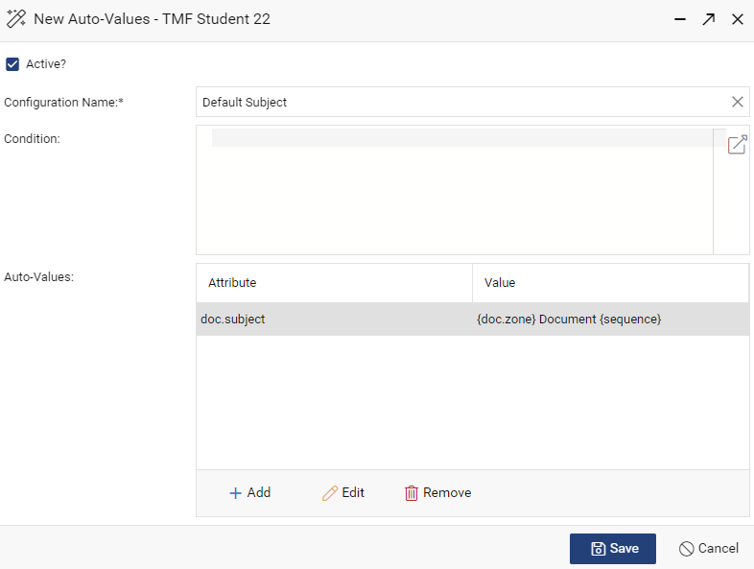

1. **Save** the auto-values configuration.

# Linking

Linking configuration defines rules for placing documents within a folder hierarchy. Typically users can browse a folder hierarchy to locate documents. Folders are optional, they are convenient for users but not a configuration requirement.

When linking rules are enabled, CARA creates the specified folder paths as required, there is no need to create folders in advance.

1. Within CARA open the **Control Panel** in the top-right corner of the user interface.
2. In the **Type Configuration** section select your type.
3. In the type configuration window select **Add** > **Processing** > **Linking**.
4. **Add** a new linking rule, which will be the default rule for user documents, with the following settings.
5. **Active**: Selected.
6. **Configuration Name**: Default User Documents
7. **Condition**: Blank.
8. Add a **Folder Path** with the following path **Elements**:
9. **Static Text**:TMF
10. **Static Text**:/
11. **Attribute Value**: doc.zone with **Unspecified Value**: unknown.
12. **Static Text**:/
13. **Attribute Value**: doc.section with **Unspecified Value**: unknown.
14. **Save** the new linking rule.

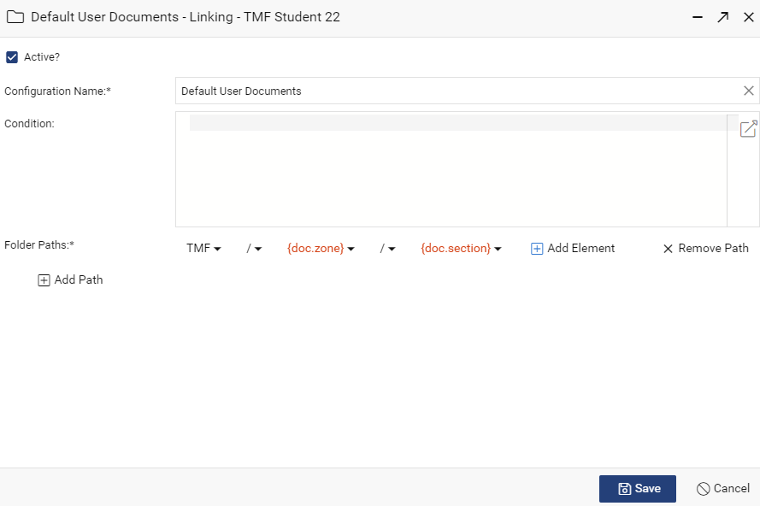

1. **Add** a second linking rule, which will be used to place document templates in a dedicated folder, with the following settings:
2. **Active**: Selected.
3. **Configuration Name**: Document Templates
4. **Condition**: is_template=true
5. Add a **Folder Path** with the following **Elements**:
6. **Static Text**:TMF
7. **Static Text**:/
8. **Static Text**: Templates
9. **Save** the Document Templates rule.

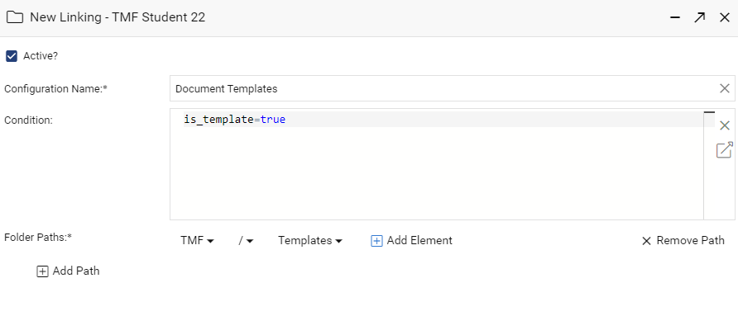

1. Ensure that the Document Templates rule is above the Default User Documents rule in the **Linking** configuration window. The order of rules is changed using click and drag.

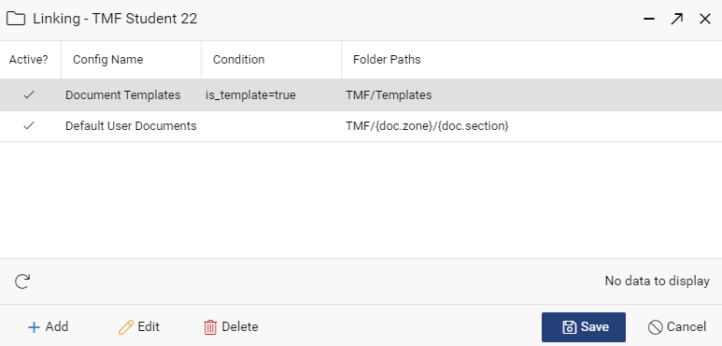

1. **Save** the linking configuration.

# Lifecycles

A lifecycle describes a series of states which a document may pass through such as draft, reviewed, approved. Each state transition can modify properties of the document.

Documents can be both promoted forward and demoted back to previous states as required. The progression of states within a CARA lifecycle does not need to be linear.

In CARA lifecycles can be applied to documents automatically at the time they are created, and moved between lifecycle states either manually by users or automatically as part of workflow.

1. Within CARA open the **Control Panel** in the top-right corner of the user interface.
2. In the **General** section select **Lifecycles**.
3. **Add** a new lifecycle, which will be the default lifecycle for user documents, with the following settings:
4. **ID**: studentx_lifecycle
5. **Display Name**: Studentx Lifecycle
6. **Add State Name as a Version Label**: Selected.
7. **Add** and **Save** the following **States**:
8. **Name**: Draft

* **Attachable**: Selected.
* **Reset to Base on Versioning**. Not selected.
* No Actions or Notifications are required for this state.

1. **Name**: Approved.

* **Attachable**: Not selected.
* **Rest to Base on Versioning**: Selected.
* **Actions**: **Type**: Promote to the Next Major Version.
* Notifications: Left blank.

1. **Add** and **Save** the following **Transitions**:
2. **Label**: Promote to Approved.

* **Source State**: Draft
* **Target State**: Approved.
* **Allow Manual Transition**: Selected.
* Other options left blank.

1. **Label**: Return to Draft.

* **Source State**: Approved
* **Target State**: Draft.
* **Allow Manual Transition**: Selected.
* Other options left blank.

1. **Save** the new lifecycle.

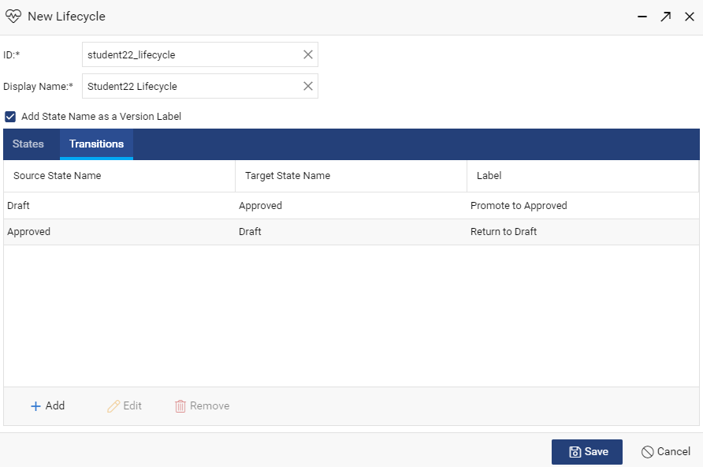

# Lifecycle Assignment

Lifecycles can be applied to documents automatically when created or imported. Each node of the main classification can have a different lifecycle assigned, or inherit the assignment from the parent classification.

Different lifecycles can be assigned to documents and templates.

1. Within CARA open the **Control Panel** in the top-right corner of the user interface.
2. In the **Type Configuration** section select your type.
3. In the type configuration panel select **Add** > **Initialization** > **Lifecycle Assignment**.
4. Highlight the root classification node tmf_studentx and untick **Settings Cascade from the Parent Classification**.
5. Set **Lifecycle for Objects** to studentx_lifecycle
6. Set **Lifecycle for Templates** to studentx_lifecycle
7. **Save** the lifecycle assignment.

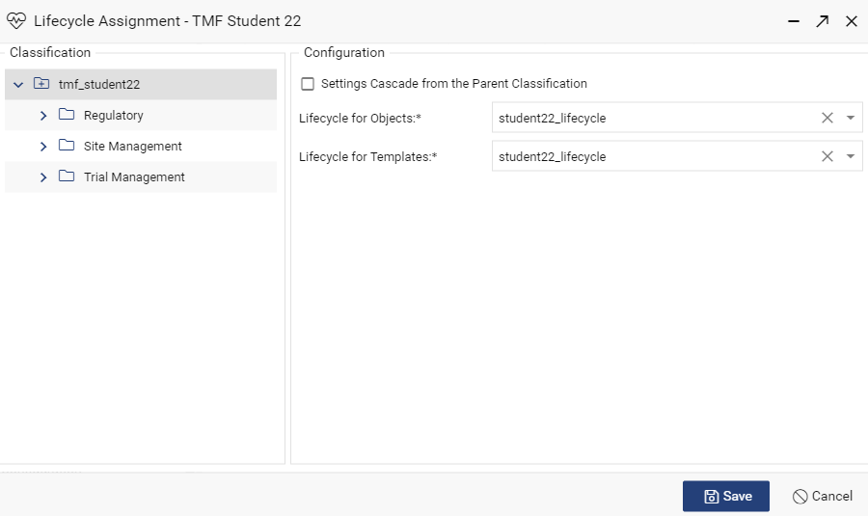

# Workflow Templates

Workflow templates describes a series of tasks to be carried out, typically as part of a process. A workflow template could consist of a single or multiple tasks.

Workflow templates can be specific to a document type and status, or can be general purpose.

Workflows templates can combine with lifecycles. When users complete tasks the workflow can automatically move the document between lifecycle states.

1. Within CARA open the **Control Panel** in the top-right corner of the user interface.
2. In the **General** section select **Workflow Templates**.
3. **Add** a new workflow template.

**General** tab settings:

1. **ID**: studentx_approval_workflow
2. **Label** Studentx Approval Workflow.
3. **Active**: Selected.
4. **Available for Manual Creation**: Selected
5. **Target Duration**: 10 Days.
6. Enter appropriate **Instructions for Workflow Initiator** such as “Please select the users who will be sent the document for approval.”

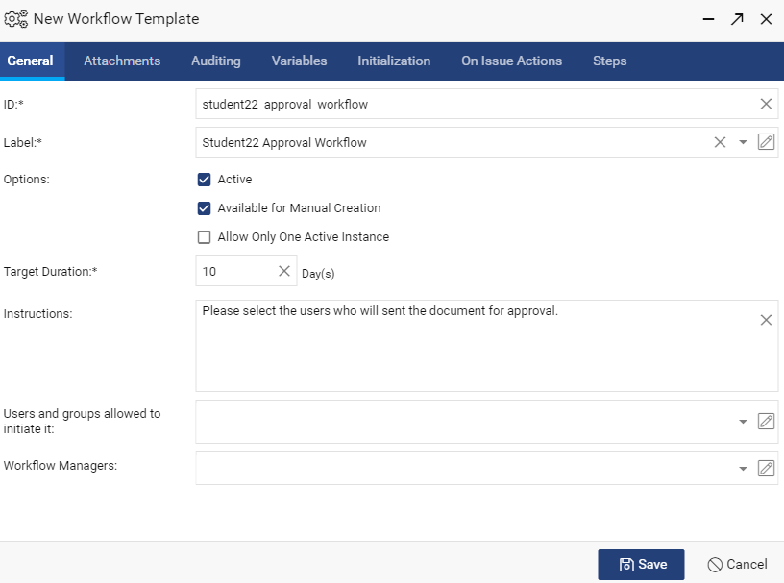

**Attachments** tab settings:

1. **Required Attachments**: Single Document.
2. **Object Type**: tmf_studentx
3. **Bind To**: Latest Version.
4. **Lifecycle**: studentx_lifecycle
5. **Lifecycle State**: Draft.

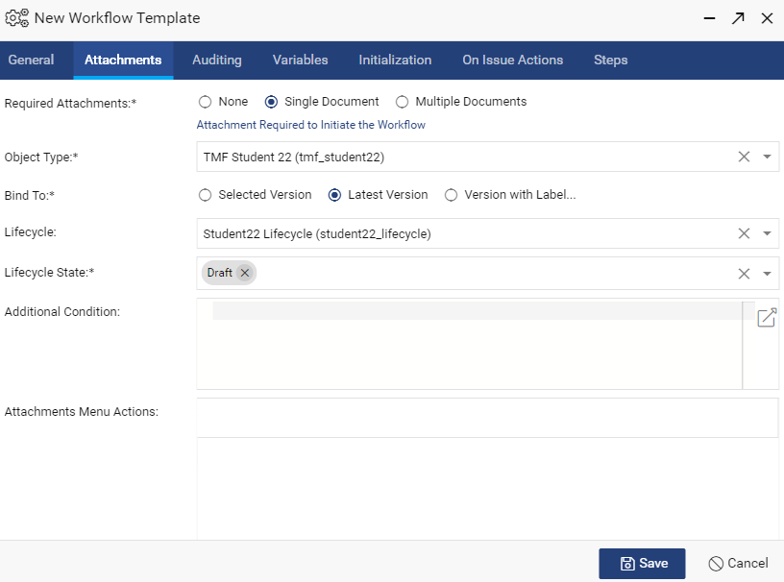

The Auditing, Variables, Initialization and On Issue Actions tabs can be left as default.

**Steps** tab Settings

1. Add a **New Step** with the following **General** tab settings:

* **ID**: approve
* **Label**: Approve
* **Priority**: High.
* **Target Duration**: 10 Days.
* Enter appropriate **Instructions** for the task recipients such as “Please approve or reject the attached document.”
* **Roles** can be left blank.

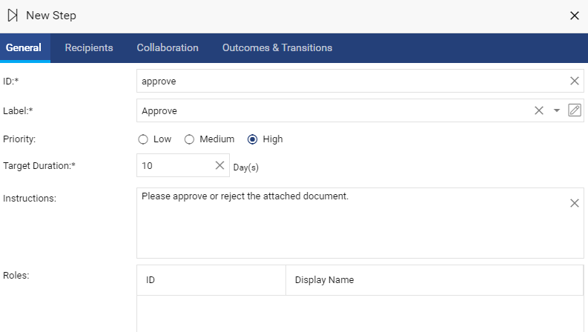

1. **New Step** > **Recipients** tab settings:

* **Sequence**: Parallel.
* Leave all other settings on the tab as default.

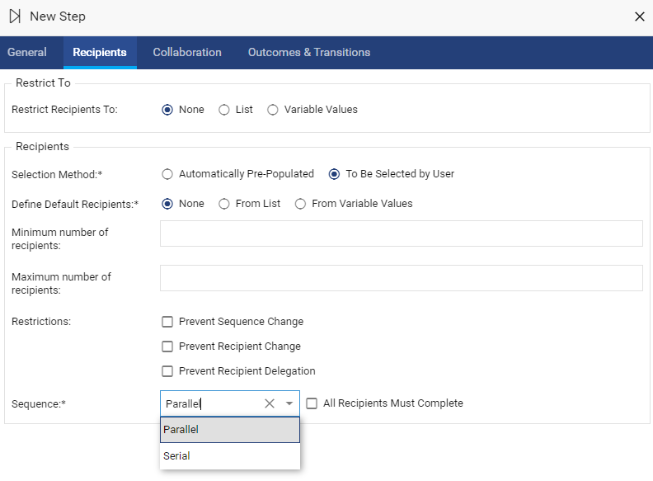

In the **New Step** > **Outcomes & Transitions** tab:

1. Add a new **Outcome** with the following settings

* **ID**: approved
* **Label**: Approved.
* **Color**: Green.
* **Comment**: Optional.
* **Signature**: Required.
* **Reason**: Not Required.

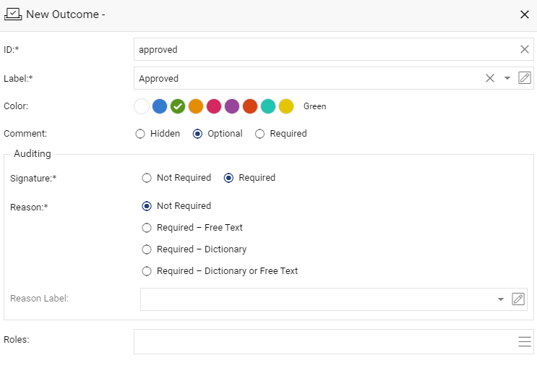

1. Add a second **Outcome** with the following settings:

* **ID**: rejected.
* **Label**: Rejected.
* **Color**: Red.
* **Comment**: Optional
* **Signature**: Required.
* **Reason**: Not Required.

1. Add a new **Transition** with the following settings.

* **Condition**: At Least One Outcome.
* **Outcome**: Approved.
* **Execute Actions**: **Type**: Change State with **Display Name**: Approved and **State**: Approved.
* **And Go To**: End.
* **Completion Status**: Document Approved and **Mark as Successful** selected.

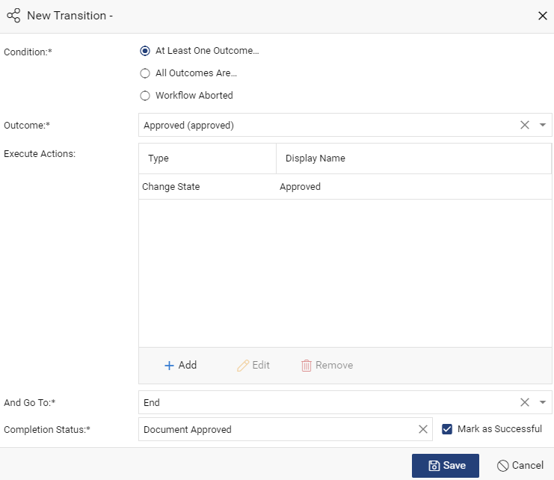

1. Add a second **Transition** with the following settings:

* **Condition**: At Least One Outcome.
* **Outcome**: Rejected.
* **Execute Actions**: **Type**: Change State with **Display Name**: Rejected and **State**: Draft.
* **And Go To**: End.
* **Completion Status**: Document Rejected and **Mark as Successful** unselected.

1. **Save** the New Step.

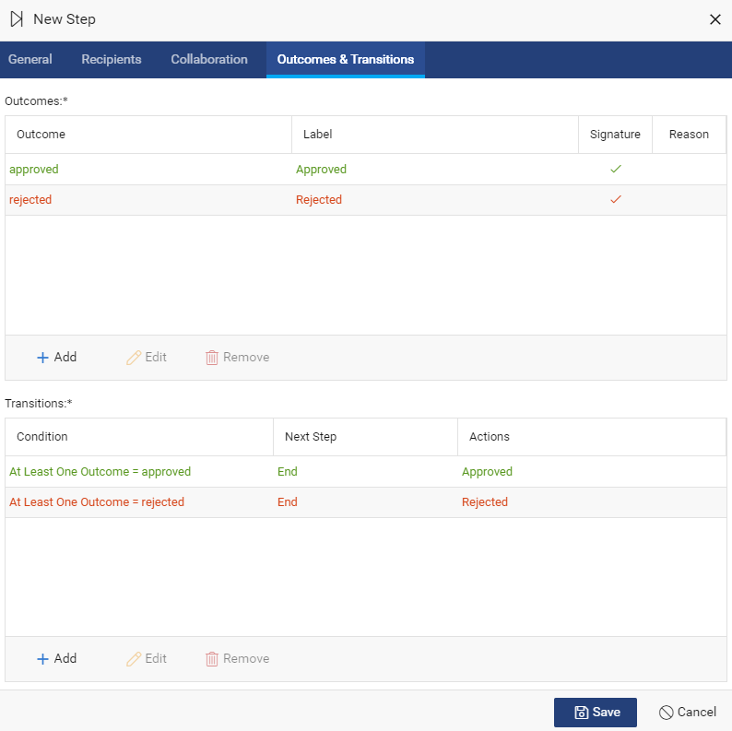

1. **Save** the workflow template.

# Test Your Configuration

Your core configuration should now be complete, documents can be created, edited and viewed. Those documents have appropriate attributes and are being placed in an automatically generated folder hierarchy.

New documents are placed in a lifecycle and workflow tasks can be sent to selected users for the approval of those documents.

A type specific view of the user interface has been provided to your users within a context.

You will test your configuration in the following section.

Note that initially no content templates have been imported, therefore only contentless placeholder documents can be created. After testing the creation of a single placeholder document, you will import a document content template to be used in the creation of subsequent documents.

1. Within the main user interface, open your studentx view and select **Create** from the File menu or toolbar buttons.
2. Create a new document with a **Classification** of your choice. The content **Creation Method** must be **Placeholder** (no content file):

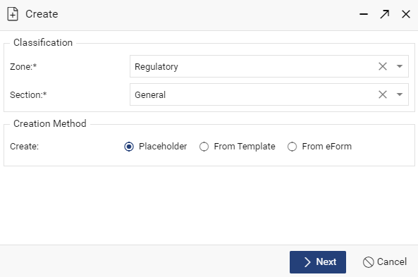

1. In the properties form give the document a **Name** of your choice. Leave other fields blank and **Save**.
2. The document is created without a content file and listed in the main view panel. Check that the document is located in the correct folder path based on the chosen classification and the version label includes Draft.
3. Import a MS Word or Excel document as a content template and associate it with a document classification:

* Select **File** > **Import Template**.
* Browse to a local document such as MS Word or Excel to import.
* In the **Import Template** window select Regulatory as the **Zone**. It should not be necessary to select a **Section**:

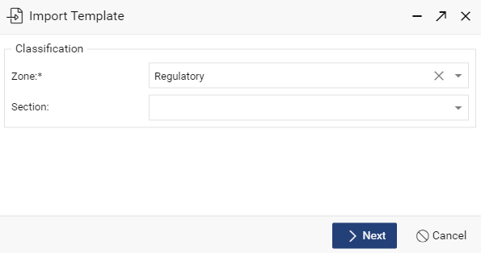

* On the properties form change the **Name** to Studentx Regulatory Template1.
* **Save** the Template. The template should be automatically placed in folder path TMF/Templates.
* Create a new regulatory document using the template.

1. Place a document in the approval workflow:

* Highlight a document that has a content file and select **Tasks** > **Send Workflow**. Select your Studentx approved workflow template.
* Select yourself as the recipient. Other settings can be left as default.
* Issue the task.
* Locate the task in your inbox.
* Examine the **Task Details** and then complete the task, approving the document.

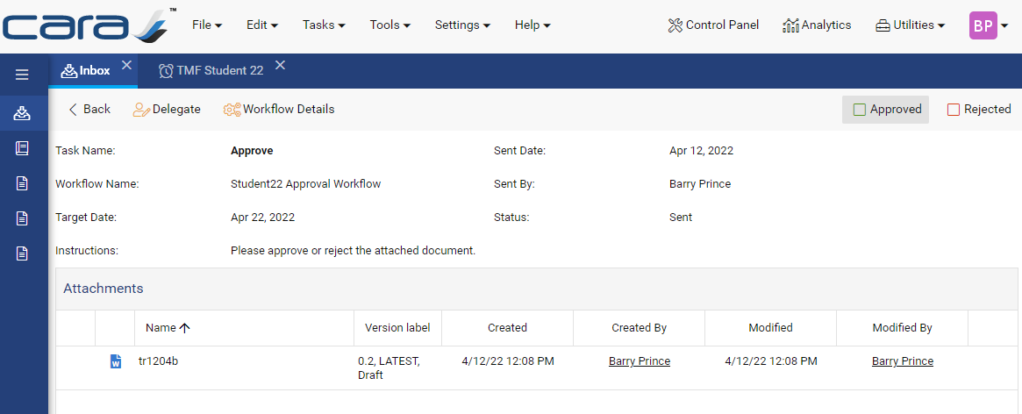

* The task will be listed in the **Completed Tasks** tab.
* Return to the TMF Student X view. Locate the newly approved document and confirm the version has been promoted to the next major version, the version label has been updated and the document is listed in green:

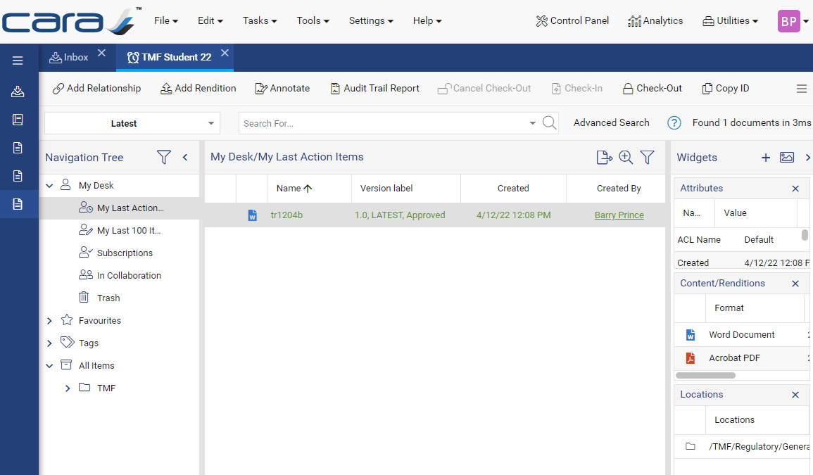

1. Congratulations you’ve successfully completed and tested you configuration!

# Export Your Configuration

With your core configuration successfully tested, now is a good time to export your configuration. Please note that the configuration export option does not include type definitions, which should be exported separately. Both are exported as .yml files.

1. Within CARA open the **Control Panel** in the top-right corner of the user interface.
2. In the **Maintenance** section select **Configuration Export**.
3. In the **Configuration Export** window leave the settings as default (Latest version and all configuration elements selected).

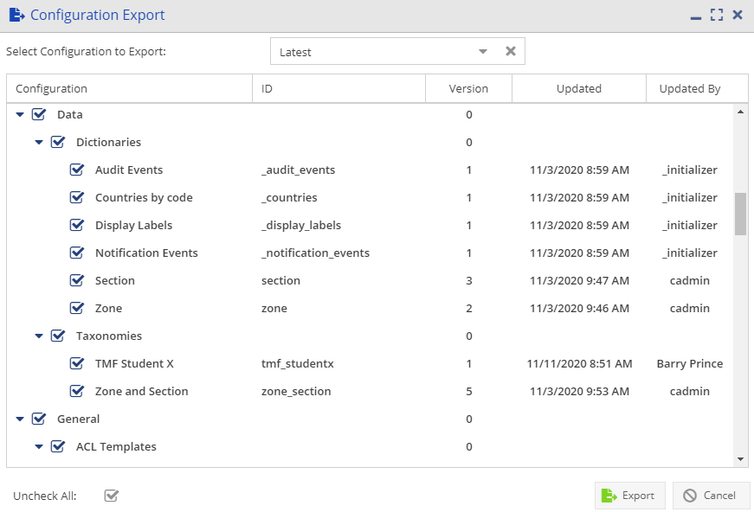

1. Click **Export to ZIP** and then open and examine the resulting zip file.
2. Back in the control panel, in the **Administration** section select **Type Definition**.
3. Highlight your type definition and select **Export** > **Export to File**.
4. Export and then locate and examine the resulting .yml file.